Star Customer Points Rewards System

Analysis by: Sumitha Sathiyanessan, Farhad Sadeghlo, Pierino Zindel

August 24, 2019

## Contents: Page:

1. Case Description 3
2. Assumptions 4
3. Class Diagram 5
4. Use Case Diagram 6
5. Use Case Descriptions, Activity & System Sequence Diagrams
   1. Customer Use Cases
      1. Create Account 7,8
      2. Search Product Catalogue 9,10
      3. Order Product 11-14
   2. Merchant Use Cases
      1. Create Account 15,16
      2. List Product 17,18
      3. Process Order 19,20
      4. Process Fees 21,22
   3. Company Use Cases
      1. Process Purchase Summary 23,24
   4. Shipper Use Cases
      1. Confirm Shipment 25-28
      2. Process Fees/Rebates 29-31
6. Design Class Diagram 32,33

## 1. Case Description

Star Customer Points Rewards System (SCPRS) is an online application that supports various companies (e.g., retailers, restaurants) to promote customer brand loyalty and increase sales. The system’s major functions are described in the following.

For every customer who has registered with a company, the company creates a unique ID for the customer, and the information is associated with each purchase made by the customer. After a purchase transaction is completed, the company sends the summarized information about the purchase (e.g., date and time of the purchase, amount paid, and points accumulated) to Star Customer Points Rewards System.

When a customer wants to redeem his/her points, he or she can go to Star Customer Points Rewards System, search product catalogue, and make an order. To confirm an order, SCPRS will email the customer order summary, projected shipping date, and updated points balance. The ordered product(s) will be shipped to the address(es) specified by the customer. SCPRS works with only two shipping companies, who rebate SCPRS for every shipping transaction.

SCPRS allows merchants of all sorts (e.g., retailers selling books, toys, flowers) to go to its web site and sell their products. Before each merchant can post their products on SCPRS, SCPRS requires the merchant to register an account. Although there is no charge for creating an account, SCPRS charges listing fees (a flat rate charged per product category [e.g., clothes] regardless of the number of products listed) and final value fees (charged based on the final sales price). Each merchant can decide the level of details for each product he or she wants to post.

## 

## 2. Assumptions

Some assumptions were made in the system analysis and breakdown of the provided case description.

It was assumed that upon creation of a customer account, the customer is provided with an account number/identifier to be used when making purchases with various companies using the SCPRS to reward points for purchases. Furthermore, it’s assumed that a customer does not need to explicitly register with a participating company to earn points, but rather the registration and assignment of a unique ID occurs upon the customers first purchase with the company.

For package (order) handling, it was assumed that it is the merchant’s responsibility to package the customer’s order and the shipping company would be notified to pick-up the package at the merchant’s facility.

## 3. Class Diagram

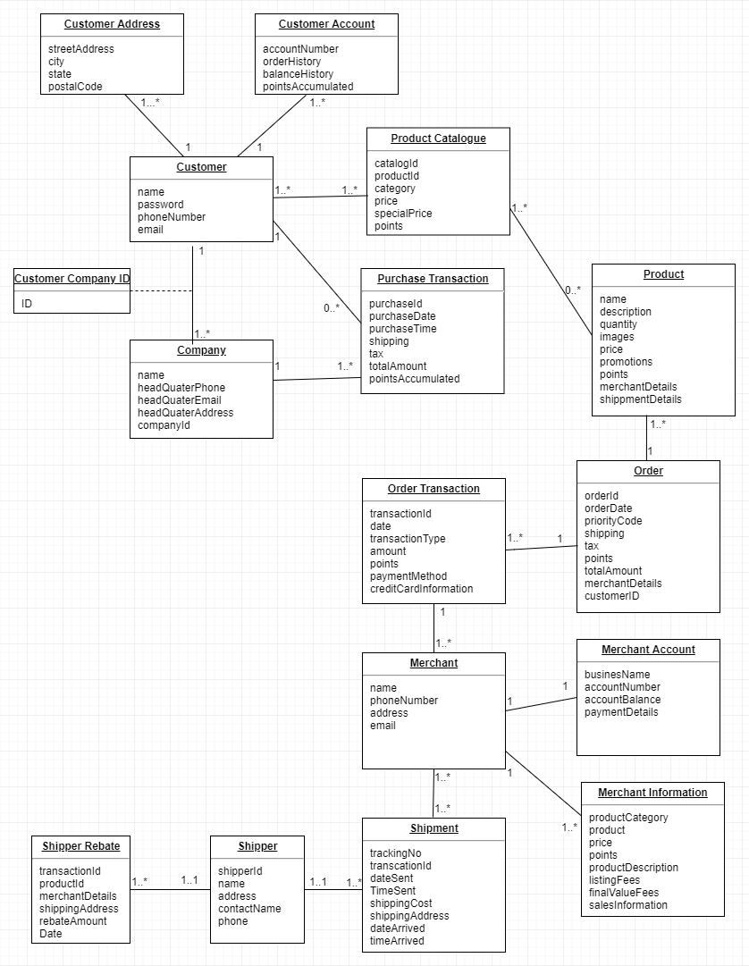

Fig.1: Domain class diagram of entire SCPRS.

## 4. Use Case Diagram

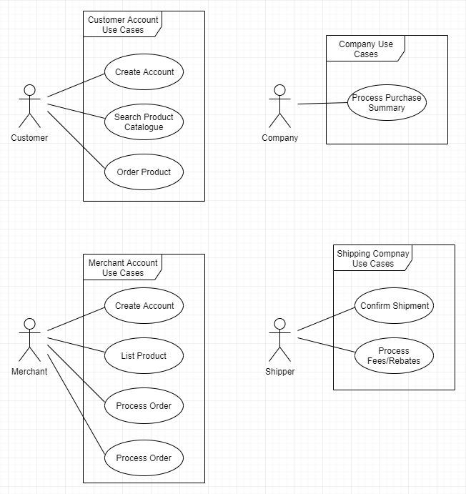

Fig.2: Use case diagram of actor interaction with SCPRS.

## 5. Use Case Descriptions, Activity & System Sequence Diagrams

### Customer Use Cases

###### Create Account

|  |  |  |
| --- | --- | --- |
| Use case name: | Create/Update customer account | |
| Scenario: | Create/Update online customer account | |
| Triggering event: | Customer request | |
| Brief description: | Online customer create/update account by entering/updating basic information like name, family name, phone number, and full address | |
| Actors: | Customer | |
| Related use cases: | Customer may refuse to just by checking out shopping cart use case | |
| Stakeholders: | Accounting, marketing, sales | |
| Preconditions: | 1. Customer account subsystem must be available  2. Points authorization services must be available | |
| Post conditions: | 1. Customer account must be created and saved  2. One or more addresses must be added to the account  3. Points info must be authorized  4. Address and account must be associated with the customer | |
| Flow of activities: | Actor | System |
| 1. Customer have desire to create or update customer account and provides the basic information as mentioned above.  2. Customer enters one or more email addresses  3. Customer enters credit/debit info  4. Systems searches for points information | 1.1 System creates new customer  1.2 System prompts for customer address  2.1 System creates addresses  2.2 System prompts for credit/debit information  3.1 System creates account  3.2 System creates an ID for the customer  4.1 System verifies authorization points  4.2 System provides validated customer account details |
| Exception Conditions: | 1.1 Basic customer data are incomplete  2.1 The address isn’t valid  3.1 No ID is associated to the customer account for some reason | |

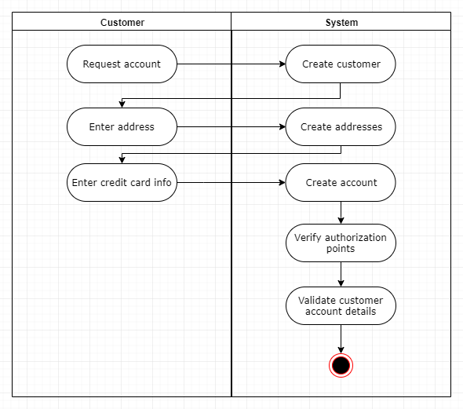

Fig.3: Activity diagram of *Create Customer Account* use case.

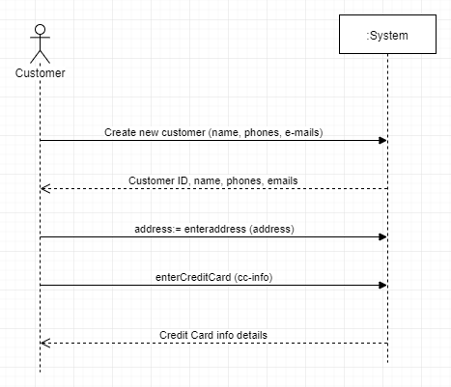

Fig.4: System sequence diagram of *Create Customer Account* use case.

###### Search Product Catalogue

|  |  |  |
| --- | --- | --- |
| Use case name: | Search product catalogue | |
| Scenario: | Search online product information | |
| Triggering event: | The person is online and searches for a product by entering the product name or the related information | |
| Brief description: | An online user types the product name or the related information, finds the product, opens the product link and sees the product full information including customer comments, ratings, shipper information and the ratings made by its customers, and be able to buy the product | |
| Actors: | Customer | |
| Related use cases: | Product listing | |
| Stakeholders: | Sales, marketing, accounting | |
| Preconditions: | 1. Customer account must have been created and be complete 2. Products must have been listed 3. Products must have a proper auto-qualified picture 4. The customer must be qualified for searching the product according to their age | |
| Postconditions: | Probably none - we may change it later | |
| The flow of activities: | Actor | System |
| 1.1. The customer searches for a product  2.1 Customer sees the system response  2.2 If any searched product is available customer clicks on it/them | 1.1 The search engine looks for the product in the database  1.2 If any search results are available system shows them to the customer, if not, the system shows no product found.  2.1 System shows the product to the customer |
| Exception Conditions: | 1.1 Nothing has been typed in the search bar  2.1 The product catalogue is not available  3.1 The product doesn’t have any/proper picture | |

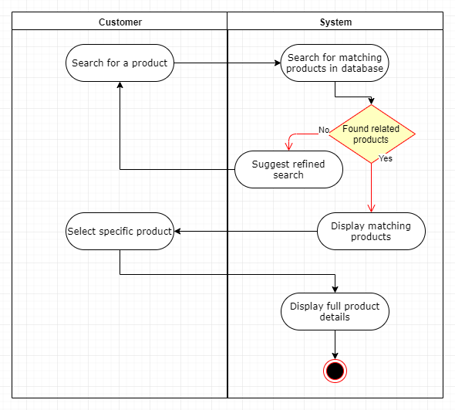

Fig.5: Activity diagram of *Search Product Catalogue* use case.

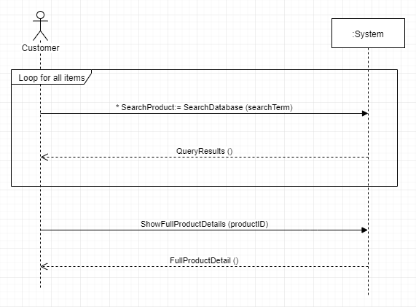

Fig.6: System sequence diagram of *Search Product Catalogue* use case.

###### Order Product

|  |  |  |
| --- | --- | --- |
| Use case name: | Create New Order | |
| Scenario: | Create online order | |
| Triggering event: | Customer Logs on to the SCPRS website and request to purchase an item | |
| Brief description: | Customer logs on and requests the new order form. The customer searches the catalog online and purchases items from the catalog. The system adds the purchased items to the order. The customer enters the credit/debit card information. | |
| Actors: | Customer. | |
| Related use cases: | Includes: Create a product catalogue  Checking product availability  Register new Customer  Redeem points for purchase | |
| Stakeholders: | Shipping Department: To verify information content is adequate for fulfillment.  Shipper: To send details of every shipping transaction to rebate the amount for SCPRS.  Merchant: To register an account and sell their products. | |
| Preconditions: | Catalogue, Products,Inventory items must exist for requested items. | |
| Postconditions: | Order and orderline items must be created.  Order transaction must be created for the order payment.  Inventory items must have the quality on hand update.  The order must be related to customer.  Order should have points updated for every transaction completed.  Merchants details must be included.  Shipping and shipper details must be created. | |
| The flow of activities: | Actor | System |
| 1. Customer Connects to SCPRS homepage.  2.1 Customer Creates Login ID.  2.2 Existing Customer Logs On .  3. Customer search product catalog.  3.1 Customer searches for points.  4. When Customer finds the correct item,he/she  requests it to be added to the order.  5. Repeat steps 3 and 4.  6. Customer request end of order.  7. Customer makes any changes.  8. Customer requests payment screen.  9. Customer enters payment information. | 2.1 Create new Customer record  2.2 Validate Customer account  2.2.a Create a new shopping cart order;  display order form with catalog frame  3. Display products from catalog based on searches and selections.  3.1 Display points associated with each purchase  4.Add item to the shopping cart  6. Display shopping cart items, with totals, amount due, points incurred:  edit and submit buttons  8.Display payment details screen  9. Accept payment, finalize order, send confirmation email. |
| Exception Conditions: | 4. If an item is not in stock, then the customer can  a. choose not to buy the item,or  b. request item to be added as a back ordered item  9. If the customer payment is rejected due to bad credit  a. order is cancelled, or  b.order is put on hold until the check is received. | |

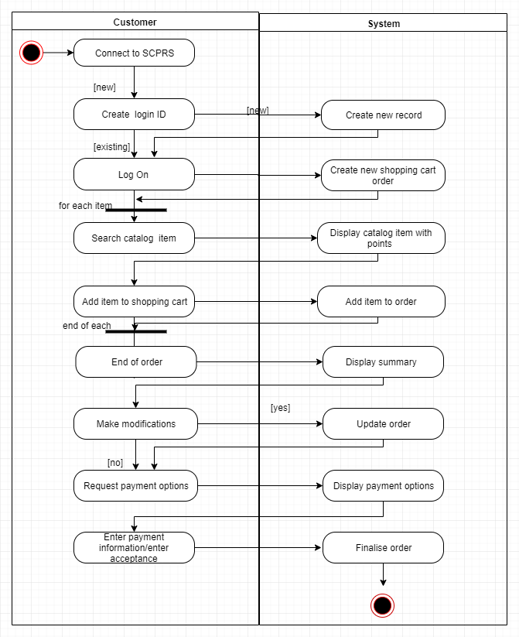

Fig.7: Activity diagram of *Create New Order* use case.

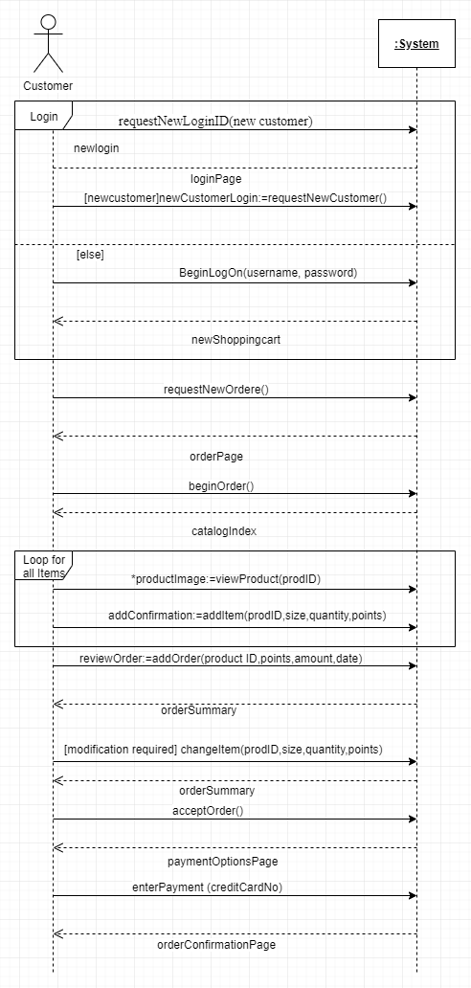

Fig.8: System sequence diagram of *Create New Order* use case.

### Merchant Use Cases

###### Create Account

|  |  |  |
| --- | --- | --- |
| Use case name: | Create merchant account | |
| Scenario: | Create a SCPRS merchant account. | |
| Triggering event: | New merchant wants to set up SCPRS account to sell goods. | |
| Brief description: | Merchant creates a merchant account by entering basic business information. | |
| Actors: | Merchant | |
| Related use cases: | Might be invoked by the *List Product* use case. | |
| Stakeholders: | Marketing, sales, participating companies, customers | |
| Preconditions: | SCPRS accounts subsystem must be available. | |
| Post conditions: | Account and addresses must be created and saved. | |
| Flow of activities: | Actor | System |
| 1. Merchant begins registration process and enters basic business information. 2. Merchant enters one or more addresses (for shipping origin). | 1.1 System creates new merchant  1.2 System prompts for merchant addresses.  2.1 System creates account.  2.2 System creates account addresses. |
| Exception Conditions: | 1.1 Basic business information is incomplete.  2.2 Invalid address. | |

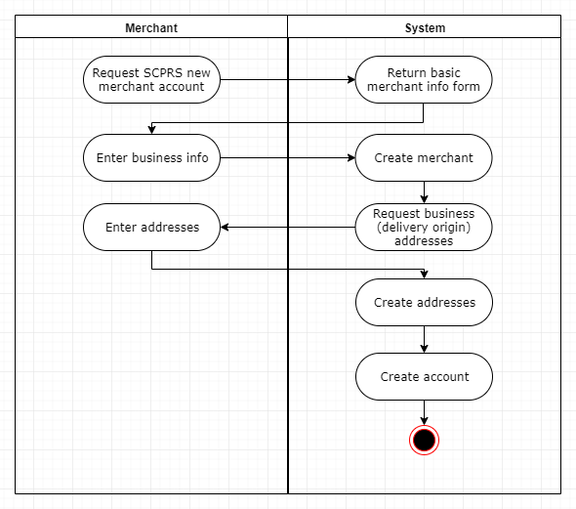

Fig.9: Activity diagram of *Create Merchant Account* use case.

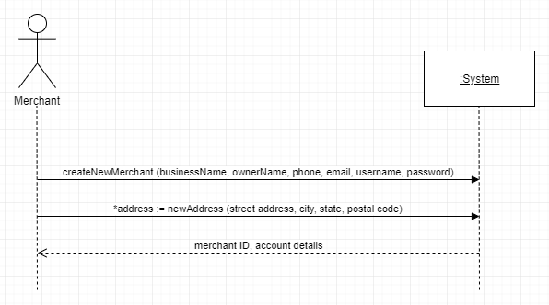

Fig.10: System sequence diagram of *Create Merchant Account* use case.

###### List Product

|  |  |  |
| --- | --- | --- |
| Use case name: | List product | |
| Scenario: | Merchant posts product(s) for sale on SCPRS. | |
| Triggering event: | Merchant wants to sell product(s) on SCPRS. | |
| Brief description: | SCPRS merchant posts their product to SCPRS by selecting a product category and entering basic product information including product name, specifications, description, image, stock, and cost. | |
| Actors: | Merchant | |
| Related use cases: | N/A | |
| Stakeholders: | Marketing, sales, participating companies, customers | |
| Preconditions: | Merchant must have active merchant account.  SCPRS accounts subsystem and product subsystem must be available. | |
| Post conditions: | Product must be searchable in SCPRS product catalogue under corresponding category.  Product listing must be associated with merchant account.  Merchants financial balance must be updated. | |
| Flow of activities: | Actor | System |
| 1. Merchant indicates desire to post product and enters basic product information. 2. Merchant selects product category. 3. Merchant confirms posting and fees. | 1.1 System creates new product listing.  1.2 System prompts for product category.  2.1 System returns product listing summary with listing fees.  3.1 System adds product listing under category in product catalogue.  3.2 System updates merchants total fees if product is listed under new category. |
| Exception Conditions: | 1.1 Incomplete product listing.  3.1 Merchant fails to confirm posting. | |

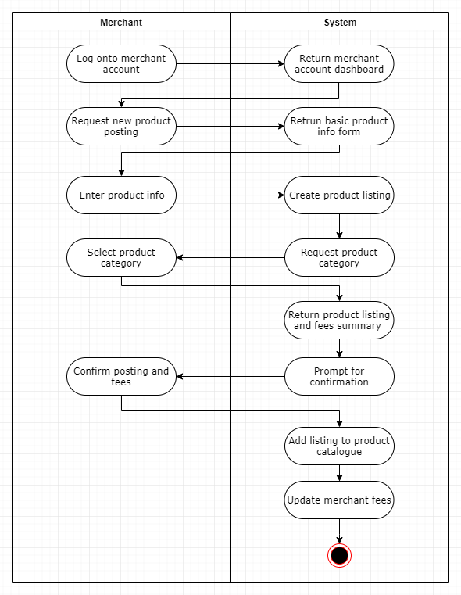

Fig.11: Activity diagram of *List Product* use case.

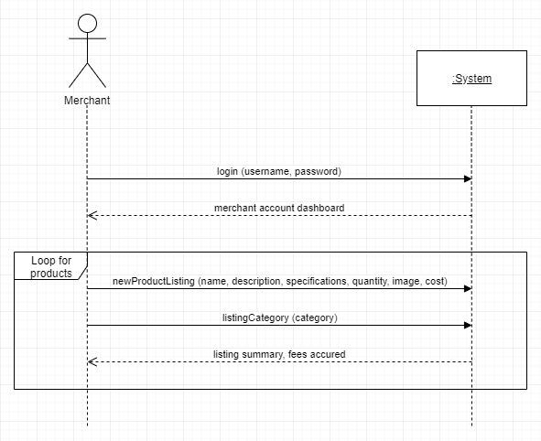

Fig.12: System sequence diagram of *List Product* use case.

###### Process Order

|  |  |  |
| --- | --- | --- |
| Use case name: | Process order | |
| Scenario: | Merchant processes a customer order. | |
| Triggering event: | Customer orders product(s) on SCPRS. | |
| Brief description: | The system notifies the merchant of a customer order. The merchant confirms the order and the system notifies the shipping company for pickup. The system updates the % final sales fees of the merchant account. The merchant prints a shipping label and passes the packaged product to the shipping company. | |
| Actors: | Merchant | |
| Related use cases: | Invoked by the *Order Product* use case used by the customer. | |
| Stakeholders: | Shipping, customers | |
| Preconditions: | Customer’s ordered product must be associated with corresponding merchant. | |
| Post conditions: | Shipping company must be notified of order pickup.  Merchant financial balance must be updated. | |
| Flow of activities: | Actor | System |
| 1. Merchant confirms order and requests shipping label. | 1.1 System notifies merchant of order.  2.1 System notifies shipping company of order pickup.  2.2 System updates merchant total fees according to final sales price of order.  2.3 System creates and returns shipping label to merchant. |
| Exception Conditions: | 2.1 Merchant fails to confirm order. | |

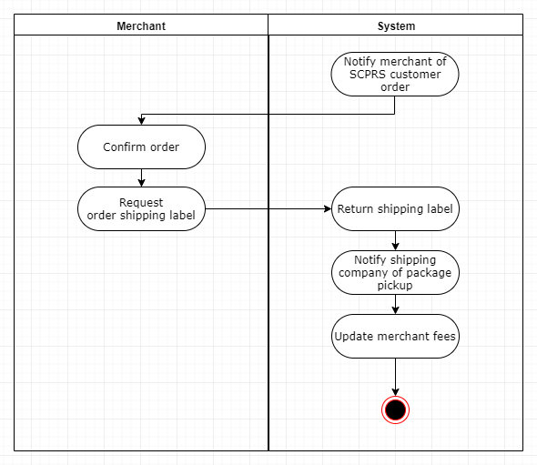

Fig.13: Activity diagram of *Process Order* use case.

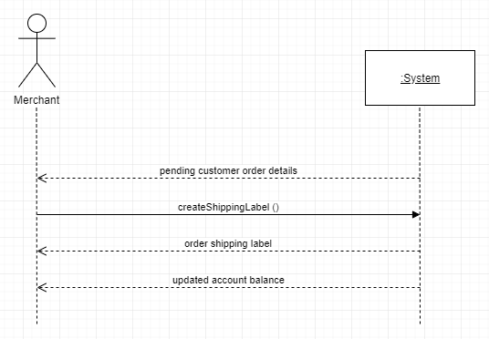

Fig.14: System sequence diagram of *Process Order* use case.

###### Process Fees

|  |  |  |
| --- | --- | --- |
| Use case name: | Process merchant fees | |
| Scenario: | Merchant pays fees associated with product categories and final sales/collects profits from sales. | |
| Triggering event: | Merchant wants/needs to pay fees/collect profits. | |
| Brief description: | SCPRS merchant views the financial standing of their account with a breakdown of the fees for posting categories and % of final sales price vs. profits from sales. Depending on balance, merchant pays fees owed or collects net profits. | |
| Actors: | Merchant | |
| Related use cases: | Might be invoked by the *List Product* use case. | |
| Stakeholders: | Accounting | |
| Preconditions: | Merchant must have an account with an outstanding balance.  SCPRS accounts subsystem must be available. | |
| Post conditions: | Payment information must be validated.  Merchant account financial standing must be updated. | |
| Flow of activities: | Actor | System |
| 1. Merchant requests account balance information. 2. Merchant indicates desire to pay fees/collect profits. 3. Merchant enters payment information. | 1.1 System returns merchant account finance summary.  2.1 System prompts merchant for payment type & info.  3.1 System validates payment info.  3.2 System processes payment.  3.3 System updates merchant account balance. |
| Exception Conditions: | 3.1 Invalid payment information. | |

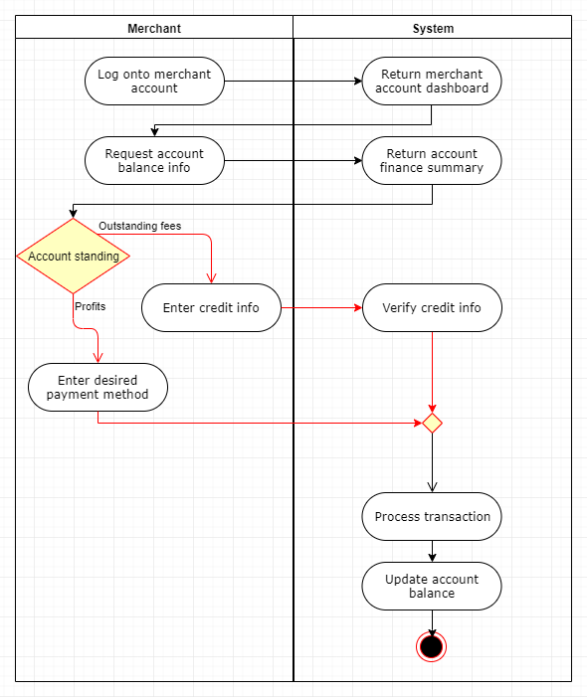

Fig.15: Activity diagram of *Process Fees* use case.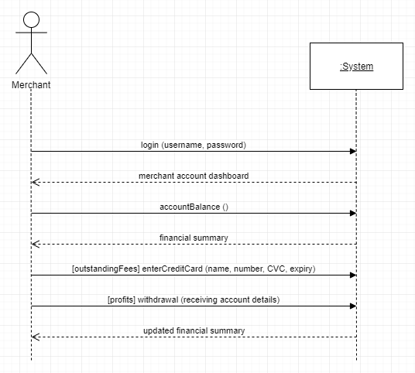

Fig.16: System sequence diagram of *Process Fees* use case.

### Company Use Cases

###### Process Purchase Summary

|  |  |  |
| --- | --- | --- |
| Use case name: | Process purchase summary | |
| Scenario: | Processing the information about customer purchase (date and time of the purchase, amount paid, and points accumulated) | |
| Triggering event: | Customer has purchased a product | |
| Brief description: | The customer purchase/s needs to be processed. The company sends the summarized information about the purchase along with the accumulated points to the customer and the SCPRS. | |
| Actors: | Customer, company | |
| Related use cases: | Create/Request user ID for the customer, order product | |
| Stakeholders: | Customer, company | |
| Preconditions: | 1. Customer must have purchased a product 2. Customer order must have been processed 3. Customer account must have a unique ID 4. Customer age must be approved to be able to buy specific products 5. Credit card info must be approved by the issuer | |
| Post conditions: |  | |
| Flow of activities: | Actors | System |
| 1.1 Customer purchases a product  1.2 Merchant requests customer ID  2.1 Company processes transaction info | 1.2 System returns customer ID (creates new if required)  2.1 System calculates the points according to the customer payment. |
| Exception Conditions: | 1.1 Customer account information is not complete (Specifically lack of unique ID)  2.1 Customer credit card gets declined and and order process stops | |

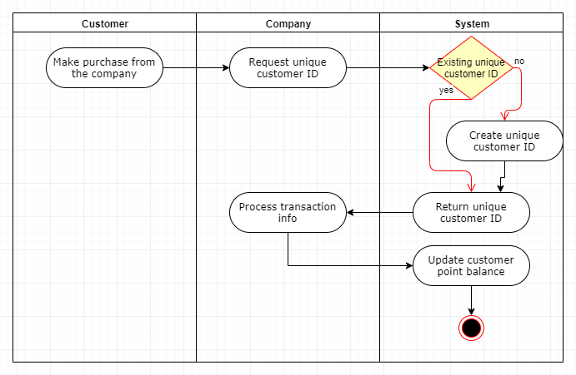

Fig.17: Activity diagram of *Process Purchase Summary* use case.

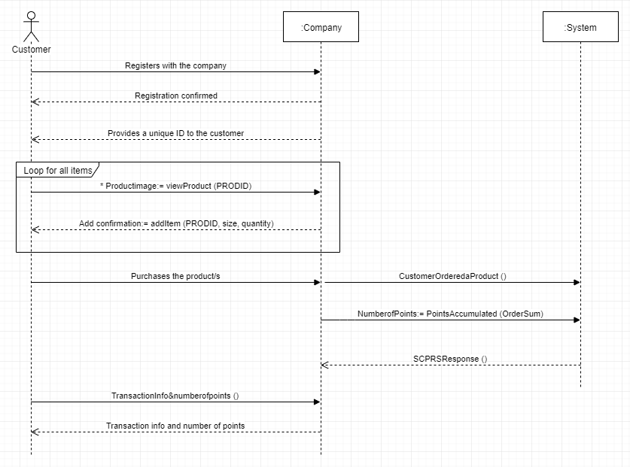

Fig.18: System sequence diagram of *Process Purchase Summary* use case.

### Shipper Use Cases

###### Confirm Shipment

|  |  |  |
| --- | --- | --- |
| Use case name: | Create shipment confirmation. | |
| Scenario: | Create online shipment confirmation | |
| Triggering event: | Customer purchases an item online and requires order confirmation. | |
| Brief description: | Customer logs on , searches the catalog online and purchases an item from the catalog . The system adds the purchased items to the order.The customer requires an order confirmation with the points accumulated, merchant and shipping information. | |
| Actors: | Customer, shipper, merchant. | |
| Related use cases: | Includes: Create a product catalogue  Checking product availability  Redeem points for purchase  Check Merchant details  Checking Shipper details | |
| Stakeholders: | Shipping Department: To verify information content is adequate for fulfillment.  Shipper: To send details of every shipping transaction to rebate the amount for SCPRS.  Merchant: To register an account and sell their products. | |
| Preconditions: | Catalogue, Products,Inventory items must exist for requested items,Points ,Merchant details, Shipper details. | |
| Post conditions: | Order and orderline items must be created.  Order transaction must be created for the order payment.  Inventory items must have the quality on hand update.  The order must be related to customer.  Order should have points updated for every transaction completed.  Merchants details must be included.  Shipping details must be created.  Shipper details must be created. | |
| Flow of activities: | Actor | System |
| 1. Customer Connects to SCPRS homepage.  2. Customer Logs On  3. Customer search product catalog.  3.1 Customer searches for points.  4. When Customer finds the correct item,he/she  requests it to be added to the order.  5. Repeat steps 3 and 4.  6. Customer request end of order.  7. Customer makes any changes.  8. Customer enters payment information.  9. Customer enters shipping information.  10.Merchant send order confirmations to customers.  11.Merchant send order summary to shipper.  12.Customer returns the product | 2.Validate Customer account  2.2.a Create a new shopping cart order;  display order form with catalog frame  3. Display products from catalog based on searches and selections.  3.1 Display points associated with each purchase  4.Add item to the shopping cart order  6.Display shopping cart items, with totals, amount due, points incurred:edit and submit buttons.  8.Display payment details screen  9.Display shipping details screen  10. Accept payment, finalize order, send confirmation email.  11.Create shipment details,order summary,confirmation email.  12.Create customer order return form. |
| Exception Conditions: | 4. If an item is not in stock, then the customer can  a.choose not to buy the item,or  b.request item to be added as a back ordered item  8. If the customer payment is rejected due to bad credit  a.order is cancelled, or  b.order is put on hold until the check is received.  11.Delay in shipment  a.Provision to cancel the shipment.  b.Reimbursement of payment. | |

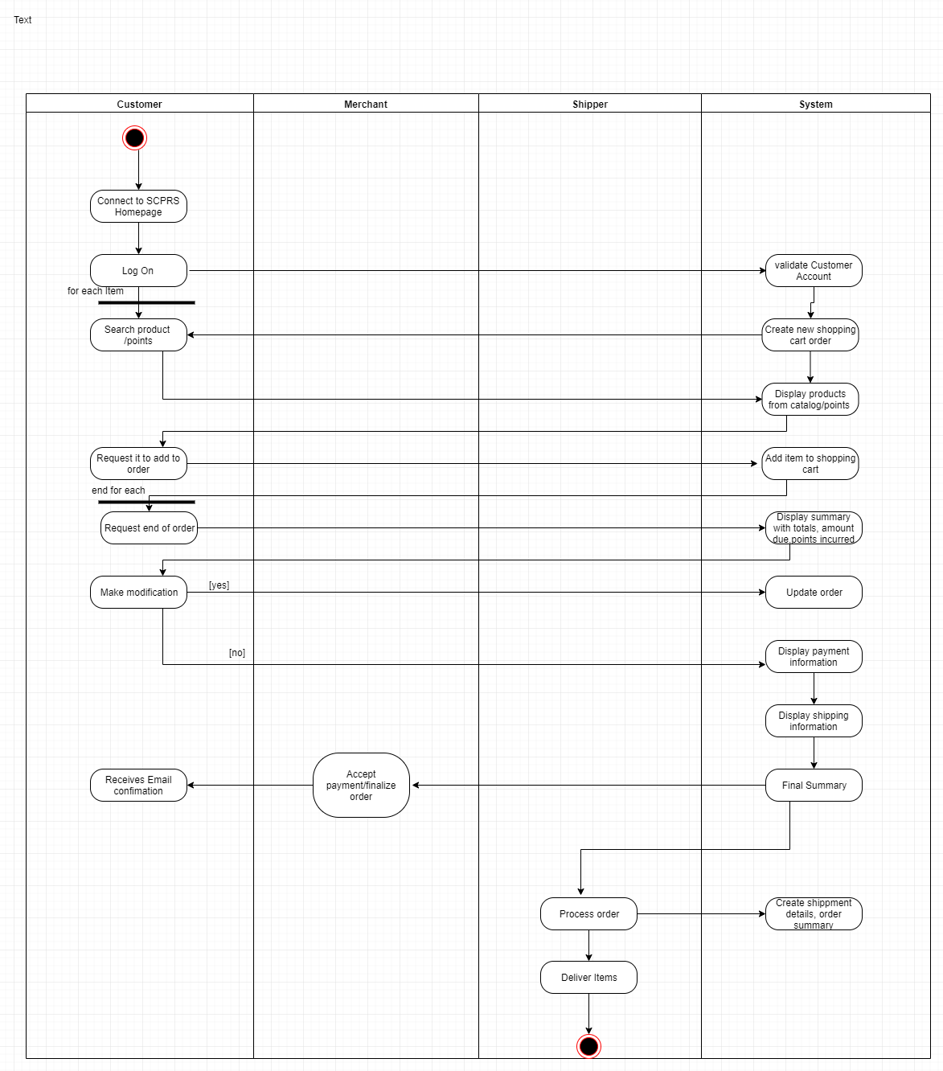

Fig.19: Activity diagram of *Confirm Shipment* use case.

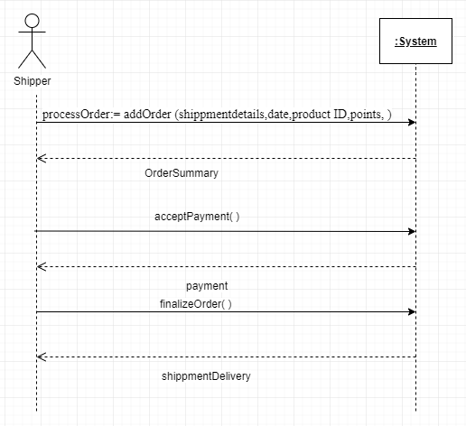

Fig.20: System sequence diagram of *Confirm Shipment* use case.

###### Process Fees/Rebates

|  |  |  |
| --- | --- | --- |
| Use case name: | Create shipper rebates. | |
| Scenario: | Create online shipper confirmation. | |
| Triggering event: | Customer makes a purchase , the merchant ships the order only through two shipping agency, For every shipment SCPRS receives rebate from the shipper. | |
| Brief description: | Customer purchases an item from the catalog .The product is shipped by the merchant to the customer only through two shipping company. For every shipment the SCPRS receives rebates from the shipper. | |
| Actors: | Customer,Merchant,Shipper | |
| Related use cases: | Includes: Process Order  Process purchase summary  Confirm Shipment | |
| Stakeholders: | Shipping Department: To verify information content is adequate for fulfillment.  Shipper: To send details of every shipping transaction to rebate the amount for SCPRS.  Merchant: To register an account and sell their products. | |
| Preconditions: | Merchant details, Shipper details. | |
| Post conditions: | Oder Summary,Shipping details must be created.  Shipper details must be created.  Rebate form to be created. | |
| Flow of activities: | Actor | System |
| 1. Customer makes a purchase.  2. Merchants sends the order summary to shipper, order below 250$ goes to shipper A, order above 250$ goes to shipper B.  3. Shipper sends rebate to SCPRS for every shipment. | 1.Accept payment, finalize order, send confirmation email.  2. Create Order summary form for shipper A and Shipper B  3. Create a rebate form for shipper. |
| Exception Conditions: | 1.Customer cancels the purchase.  a. Cancellation should be made within 2 days  2. Merchants sends wrong Order summary to shipper  a. Separate rebate form for that case should be created.  3. Late payment of rebates.  a. Fines should be included in the rebate form. | |

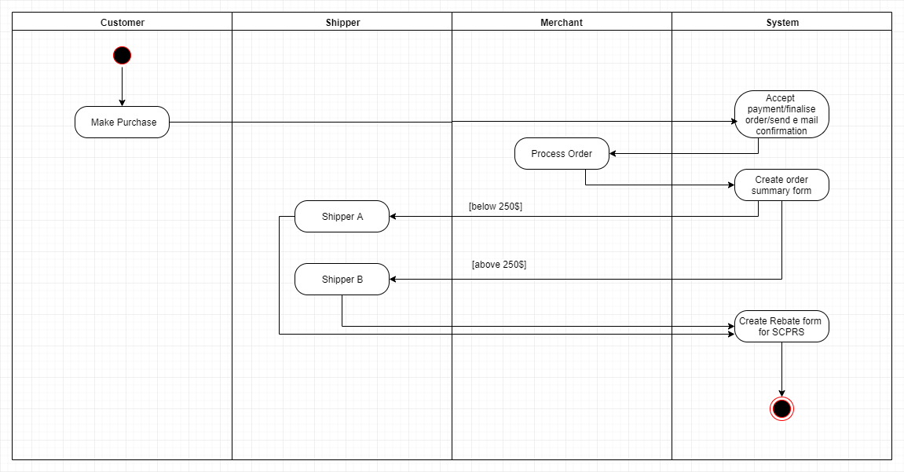

Fig.21: Activity diagram of *Create Shipper Rebates* use case.

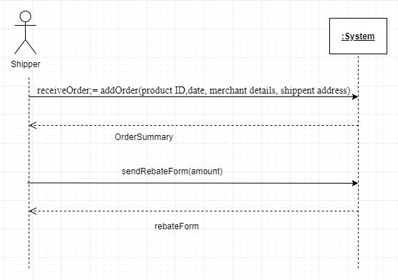

Fig.22: System sequence diagram of *Create Shipper Rebates* use case.

## 6. Design Class Diagram

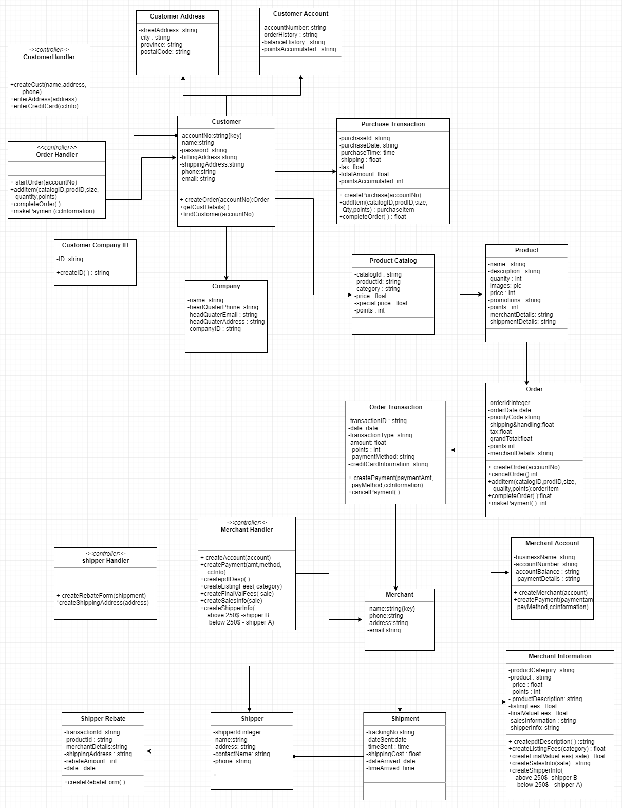

Fig.23a: Design class diagram of SCPRS (continued below).



Fig.23b: Design class diagram of SCPRS (proceeded above).